ADMIN PORTAL – COMPLETE STRUCTURE
No. | Module | Features
1 | Dashboard | Business overview, KPIs and alerts
2 | Client Management | Add clients, contracts and client users
3 | Employee Management | Employee profiles and records
4 | Employee Onboarding | Registration, documents and eKYC
5 | Attendance Management | Check-in, check-out and exceptions
6 | Geofencing | Sites, boundaries and location events
7 | Workforce Deployment | Assign employees to clients and sites
8 | ID Card Management | Generate and deactivate IDs
9 | Document Management | Employee and client documentation
10 | Reports & Analytics | Business and workforce reporting
11 | Billing & Contracts | Invoices and contract tracking
12 | User & Role Management | Access permissions
13 | Notifications | Alerts and announcements
14 | Settings | Company, branch and application settings

Admin dashboard KPIs
- Total employees.
- New employee registrations.
- KYC pending.
- Employees deployed.
- Employees not deployed.
- Present/absent employees.
- Active client contracts.
- Active work locations.
- Pending complaints.
- Pending approvals.
- Monthly manpower cost, if payroll/cost data is integrated.

HR PANEL

HR Panel – Sidebar Structure
No. | Module | Features
1 | Dashboard | HR overview, employee statistics, onboarding KPIs and alerts
2 | Employee Onboarding | Register new employees, create employee records and initiate onboarding
3 | Employee Management | View, search, edit and manage employee profiles
4 | eKYC Verification | Aadhaar QR or authorised eKYC, verification status and history
5 | Document Management | Upload, review and verify employee documents
6 | Employee ID Card | Generate, download, print and deactivate employee ID cards
7 | Client & Site Assignment | View employee assignment details and coordinate with Operations
8 | Department & Designation | Create and manage departments, job roles and designations
9 | Payroll Information | Maintain payroll-related employee inputs and employment details
10 | Employee Reports | Employee database, onboarding, KYC and document reports
11 | User & Access Management | HR users, permissions and access controls

Employee Onboarding – Complete Workflow
1. Employee Registration – HR enters basic details and creates a new employee record.
2. Employee Information – Capture name, photograph, mobile number, address, date of birth, emergency contact, designation and department.
3. Document Collection – Collect permitted identity, address, education and employment documents, as applicable.
4. eKYC Verification – Verify identity using the selected authorised eKYC method or Aadhaar Secure QR.
5. HR Review and Approval – HR checks information, documents and verification status before approving onboarding.
6. Employee ID Generation – The system automatically generates a unique employee ID.
7. ID Card Generation – Generate the employee ID card with photograph, employee ID, designation and QR code.
8. Account Creation – Create employee login credentials and send an invitation or temporary password securely.
9. Operations Handover – The approved employee becomes available for Operations to assign to a client, site and shift.

Employee Onboarding Form – Required Fields
Section | Information required
Personal details | Name, date of birth, gender and photograph
Contact details | Mobile number, email and residential address
Emergency details | Emergency contact name, number and relationship
Employment details | Designation, department, employment type and joining date
Identity verification | Selected KYC method and verification status
Documents | Identity, address, education and employment documents, as applicable
Bank details | Bank account information, collected securely only if required for payroll
System details | Employee ID, login account and account status

OPERATIONS PANEL

Operations Panel – Sidebar Structure
No. | Module | Features
1 | Dashboard | Operational overview, site KPIs, workforce status and alerts
2 | Client & Site Management | View clients, create/manage sites and service locations
3 | Workforce Deployment | Assign employees to clients, sites and supervisors
4 | Employee Directory | View HR-approved employee profiles and availability
6 | Geofencing & GPS | Configure site boundaries, view location events and exceptions
7 | Task Management | Create, assign and track site-level tasks
8 | Daily Work Reports | Submit, review and approve site and employee reports
9 | Incident Management | Record accidents, safety incidents and escalations
10 | Operations Reports | Site, workforce, attendance, shift and performance reports

Geofencing
- Operations creates the client site in the website.
- The site location is saved using GPS coordinates.
- Operations sets a geofence radius, for example, 100 metres.
- The employee logs in through the mobile app.
- When the employee is within the permitted area, the app allows punch in.
- When the employee punches out, the app records the time and location.
- Attendance is automatically updated in the Operations and HR panels.

Oparation Scope
- Operations dashboard
- Client and site management
- Workforce deployment
- Employee directory linked to HR-approved records
- GPS geofence configuration
- Daily work reports
- Operational reports and notifications

Client Mobile App

Client App – Main Features
No. | Module | Features
1 | Client login | Secure client account login
2 | Dashboard | Total deployed employees, present employees, absent employees and number of assigned sites
3 | Employee Deployment | View employees assigned to the client's organisation and locations
4 | Site Attendance | View present, absent, late and punch-in/punch-out details
5 | Site Details | View assigned sites and workforce strength at each site
6 | Reports | Daily, weekly and monthly attendance reports
7 | Notifications | Attendance updates and important alerts
8 | Profile | Client account details and logout

Employee Deployment Screen
Clients should be able to view employees assigned to their organisation.
Employee ID | Employee Name | Designation | Site
SS1001 | Employee A | Housekeeping | Site A
SS1002 | Employee B | Security | Site A
SS1003 | Employee C | Technician | Site B
SS1004 | Employee D | Housekeeping | Site B

Final Client App Scope
- Client login
- Dashboard
- Employee deployment details
- Site-wise employee list
- Present and absent employee count
- Employee punch-in and punch-out records
- Attendance reports
- Basic notifications

EMPLOYEE APP REQUIREMENTS
1. Employee login
- Login using Employee ID and password.
- Forgot password / password reset.
- Secure logout.
2. Employee Information
- Employee name and ID.
- Photograph.
- Designation and department.
- Assigned client/site.
- Reporting supervisor.
3. GPS and geofencing attendance
- Verify employee's GPS location.
- Check whether the employee is inside the assigned worksite geofence.
- Enable Punch In only when the employee is within the permitted area.
- Enable Punch Out based on the configured attendance policy.
- Record date, time, GPS coordinates and site.
4. Attendance confirmation
- Show successful Punch In / Punch Out.
- Display the recorded time.
- Show an error if the employee is outside the permitted geofence.

Praposed Arcitecture
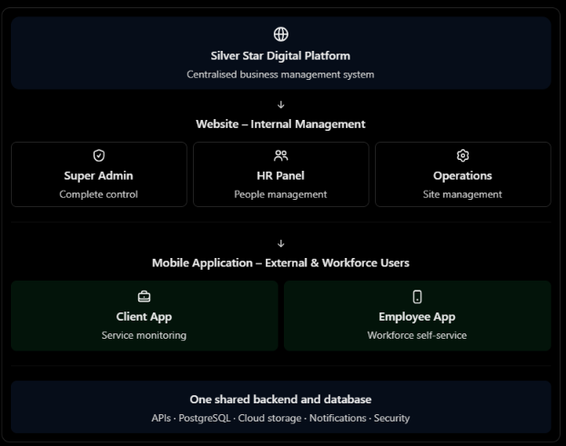
How GPS geofencing will work
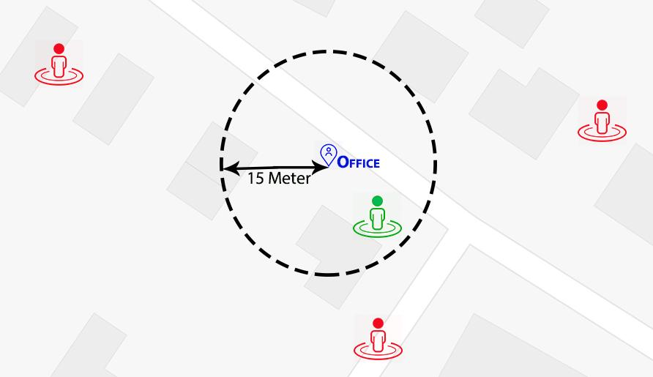
- Operations creates the client site in the website.
- The site location is saved using GPS coordinates.
- Operations sets a geofence radius, for example, 100 metres.
- The employee logs in through the mobile app.
- When the employee is within the permitted area, the app allows punch in.
- When the employee punches out, the app records the time and location.
- Attendance is automatically updated in the Operations and HR panels.

Proposed Technical Architecture
Layer | Recommended technology | Purpose
Web frontend | React.js with TypeScript | Super Admin, HR and Operations web panels
Mobile frontend | React Native | Android and iOS app with role-based Client and Employee access
Backend/API | Python FastAPI | Business logic, authentication, permissions, attendance and integrations
Database | PostgreSQL | Central relational data store
File storage | AWS S3 or equivalent object storage | Employee photos, permitted documents, reports and generated ID-card PDFs
Cloud hosting | AWS (Mumbai region where appropriate) or equivalent | Application hosting, database, storage, monitoring and backups
Push notifications | Firebase Cloud Messaging / Apple Push Notification service | Mobile notifications where required
Maps/location | Google Maps Platform or equivalent map provider | Site location selection and map display; GPS coordinates from device location services
PDF/QR generation | Backend PDF and QR-code libraries | Employee ID-card generation and QR verification

Application Architecture and Data Flow
- All three web panels and both mobile app experiences must communicate with the same backend through secured APIs.
- The backend must enforce permissions and client/site data boundaries; hiding a screen in the frontend is not sufficient security.
- Employee records created and approved by HR must become available to Operations for deployment.
- Operations site assignments and shift schedules must be used by the Employee App during attendance validation.
- Attendance events must be available to authorised HR, Operations, Super Admin and the relevant client users.
- Clients must only access their own organisation's assigned employees, sites and attendance records.

Functional Technical Requirements

5.1 Authentication and Access Control
- Secure login for all website users and mobile app users.
- Employee login using Employee ID and password.
- Client login using credentials issued by an authorised administrator.
- Role-based access control for Super Admin, HR, Operations, Client and Employee.
- Password hashing using a recognised secure password-hashing algorithm; never store plaintext passwords.
- Password reset, account activation/deactivation, session expiry and logout.
- Multi-factor authentication for privileged website accounts is recommended.
- Record security-sensitive account and permission changes in audit logs.

5.2 Employee Onboarding and HR
- Create and maintain employee profiles with unique employee IDs.
- Capture required personal, contact, emergency and employment information.
- Support document upload, review, approval and rejection with reason/status.
- Integrate a legally permitted KYC method or support Aadhaar Secure QR offline verification as approved for the use case.
- Track KYC status and verification reference without unnecessarily retaining Aadhaar data.
- Generate employee ID cards containing approved fields and a unique QR code.
- Create or activate employee app accounts after HR approval.
- Maintain employee status and assignment/employment history.

5.3 Client and Site Management
- Create clients, client contacts, service locations and sites.
- Store each site name, address, latitude, longitude, geofence radius and active status.
- Allow authorised Operations users to select a site location on a map and configure its boundary.
- Maintain client-specific site and workforce records.
- Support site-specific shifts and employee deployment.

5.4 Workforce Deployment and Shifts
- Assign HR-approved employees to a client, site, designation and supervisor.
- Maintain assignment start date, end date and assignment history.
- Create shifts with start/end times, applicable days, grace periods and effective dates.
- Prevent or flag conflicting assignments and shift overlaps according to configured rules.
- Make current assignment and shift details available to the Employee App for attendance checks.

5.5 GPS Geofencing and Attendance
- Use device location services to obtain the employee's location when Punch In or Punch Out is selected.
- Send employee ID, assigned site ID, coordinates, event timestamp and reported location accuracy to the backend over HTTPS.
- Validate that the employee is assigned to the site and that the site/geofence is active.
- Calculate distance between the device coordinates and the configured site coordinates using a recognised geographic-distance calculation.
- Accept the punch only when the employee is within the configured radius and location accuracy meets the configured rule.
- Validate shift and attendance state, including duplicate punch-in and missing/invalid punch-out conditions.
- Store the original attendance event, validation result, server receipt time and relevant location metadata.
- Provide an exception workflow for GPS unavailable, low accuracy, device permission denied or other genuine failures.
- Allow authorised manual corrections with a mandatory reason and audit trail.
- The initial release should use event-based location checks at punch-in and punch-out, not continuous background tracking.
Geofencing limitation: GPS accuracy varies indoors, near tall buildings and across devices. A geofence is a location check, not proof of identity or an infallible boundary. Mock-location and spoofing checks may reduce misuse but cannot guarantee prevention. Site radius and accuracy thresholds must be tested at real sites.

5.6 Client Mobile App
- Provide client login.
- Display total employees deployed, present today, absent and assigned sites.
- Show employees assigned to the client's sites.
- Show site-wise deployed, present and absent counts.
- Display permitted attendance details, including punch-in and punch-out times.
- Provide daily, weekly and monthly attendance reports.
- Do not expose Aadhaar/eKYC details, bank details, private HR documents or another client's data.
- Do not include payroll, employee onboarding or unrelated workflow features in the initial client app.

5.7 Employee Mobile App
- Provide Employee ID and password login.
- Display basic employee information and current assigned site/shift.
- Provide Punch In and Punch Out actions.
- Request location permission and validate device location at the time of each punch.
- Display clear success, outside-geofence, GPS-unavailable and low-accuracy messages.
- Display basic current-day attendance status.
- Do not include leave, salary, chat, task management or document upload in the initial employee app.

Third-Party Services and Integrations
Service | Requirement / consideration
KYC provider | Use an authorised provider and legally permitted integration route; confirm onboarding eligibility, consent, pricing and contractual terms.
Maps provider | Map display and site pin selection; check API usage and billing.
Cloud hosting | Application hosting, managed database, storage, backups and monitoring.
Push notifications | FCM for Android and APNs for iOS, subject to app configuration.
SMS/email provider | Optional OTP, invitations, password reset and operational notifications; provider charges apply.
App stores | Google Play and Apple App Store developer accounts and review compliance.

Deployment and Environments
- Maintain separate development, testing/staging and production environments.
- Use version control and a controlled release process.
- Protect production credentials and secrets; do not hard-code them in source code.
- Configure automated database backups and application monitoring.
- Set up domain names and HTTPS certificates for the website and API.
- Publish Android and iOS apps through the relevant app stores or approved distribution channels.
- Provide administrator training and handover documentation.

11. Testing and Acceptance Criteria
- Verify each role can access only its permitted screens and records.
- Verify client users cannot access another client's sites, employees or attendance.
- Test employee onboarding, document review, KYC status handling and ID-card generation.
- Test employee deployment and shift assignment, including changes and transfer history.
- Test punch-in and punch-out inside and outside the geofence.
- Test low GPS accuracy, denied location permission, GPS unavailable and network interruption cases.
- Test duplicate punch-in, missing punch-out and approved attendance correction.
- Verify client dashboard counts against the underlying attendance records and configured shift rules.
- Test reports, exports, audit logs, backups and restore procedures.
- Conduct security and mobile-device testing before production release.

